Psalm 119:105
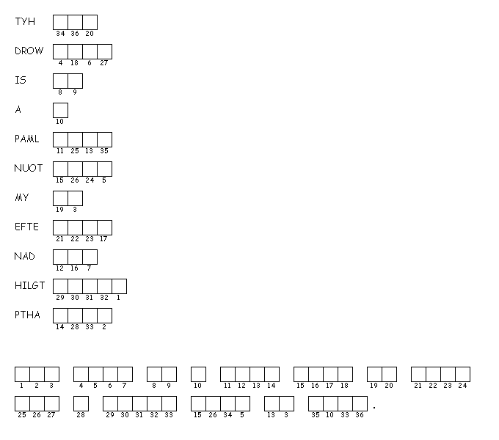
Unscramble each of the clue words.
Copy the letters in the numbered cells to other cells with the same number.

